HHS NIH STTR/SBIR Grant Application Submission Plan (12-step process)
- Find relevant topic and develop the one-page “Specific Aims” (Project Summary) to submit to the NIH Program Manager for his/her review and comment to decide whether or not to proceed
  - Problem Statement (Why is it important?)
  - Proposed Solution (What is the expected impact?)
  - Overall Goal and Specific Aims (state what you intend to do and by when)
  - Assuming you prove feasibility in Phase I close with expected results in Phase II
- Finish required Registrations – do these early as it takes several weeks to complete
  - DUNS
  - SAM
  - SBA – you will receive a SBA Company Registry as a PDF file (see step 10)
  - eRA Commons
  - Grants.gov
  - ASSIST (submission portal)
- Solidify your Project Team
  - Need dedicated PI w/ relevant project management and technical experience
  - Need clinical professional
  - Need NIH bio-sketches from all team members (must follow NIH format)
- Determine available tools/resources needed to be obtained using grant funding and determine how much grant funding you need ($100K to $225K with waiver)
- Obtain Letters of Support from:
  - Collaborators (i.e. University) and consultants that will contribute to this research
  - Organization(s) that would be an interested customer or test site
  - Organization(s) that would provide matching funds if any awarded (i.e. State agency)
- Develop materials needed to populate the Research Plan
  - Must have team solidified and research strategy roughed out for what you intend to do and Statements of Work for subawards that are agreed to by all parties.
  - Must have planned budget allocations for research funds including subawards
  - Must provide information on current state of intellectual property
  - Understanding of market position, competition, and barriers to entry
  - Must provide paragraph to summarize the company capabilities. Details regarding previous research and commercialization history is helpful.
- Solidify detailed Research Plan content
  - Determine a scientific approach to accomplish specific aims
  - Design an experiment to test your hypotheses
  - Determine key project risks and mitigation strategies
  - Determine quantitative success metrics
  - Determine SBIR research timeline and task assignments (Gantt Chart)
  - Determine specific research steps/milestones and elaborate on the resources required to complete (i.e. elaborate on what is defined in Gantt chart)
  - Create diagrams/charts that help illustrate key concepts
  - Develop bibliography and references cited
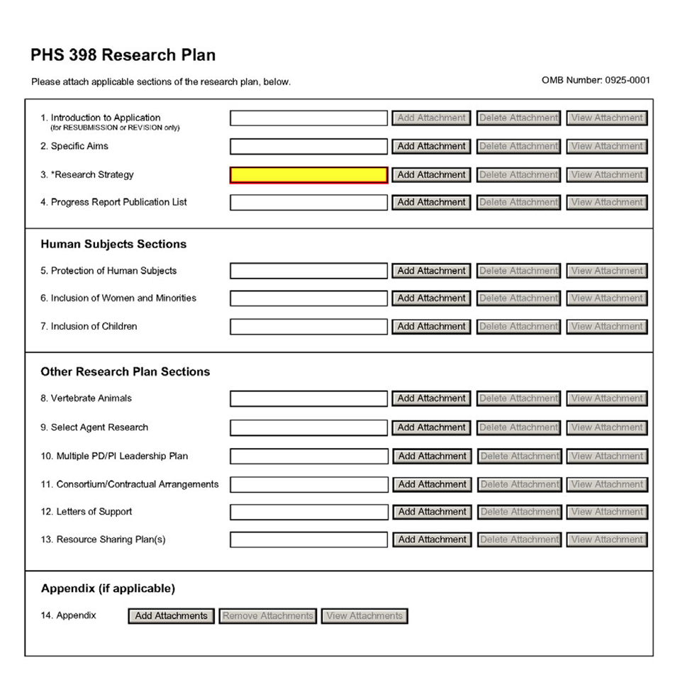
- Complete first draft of Research Strategy (6 pages) with the following sections:
  - Significance
  - Innovation
  - Approach (How are specific aims achieved?)
  - Preliminary Data (Describe what you have accomplished to date)
  - Project Team (Define roles and qualifications – bios will contain details)
  - Relevant Experience (What past work has organization done that is relevant?)
  - Anticipated Future Plans (for Phase II and beyond)
- Develop detailed budget excel spreadsheet to match with resources as stated in research plan
  - Direct labor hours and labor rates of all key participants (salary cap is $187K/year)
  - Determine employee fringe benefits (Social Security and Medicare deductions, health care insurance, vacations, sick leave, retirement plans, etc.)
  - Determine other direct costs (University subcontract, consultants, materials & supplies)
  - Determine indirect cost rate and desired profit or fee
  - Develop budget justification narrative
  - Include contractual agreements with University and others that will be under contract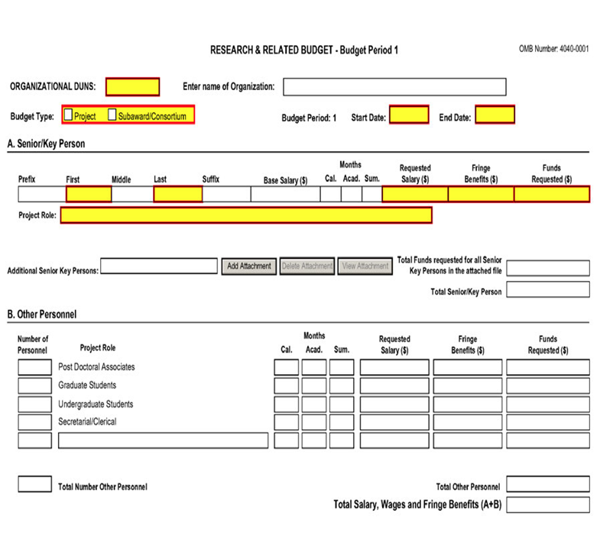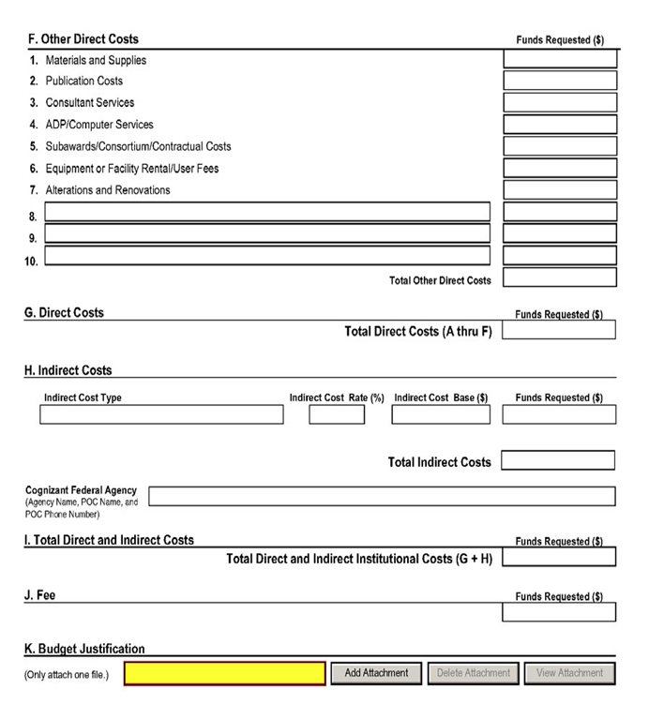

- Develop supplemental documents
  - Develop project abstract (one paragraph non-proprietary)
  - Develop project narrative (one paragraph on how it relates to mission)
  - Develop facilities and other resources description
  - Develop equipment description
  - Develop any additional required documents such as plans for testing human subjects and vertebrae animals
  - Attach proof of registration with the SBA Company Registry in Question 12
  - Cover Letter to request appropriate study section or use PHS Assignment request Form
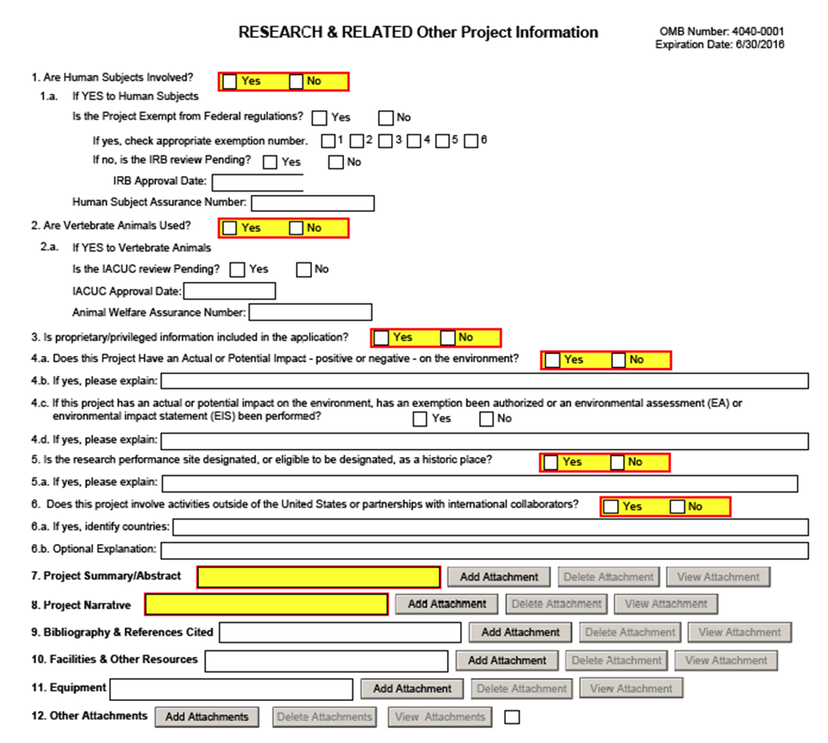
- Red Team Review of proposal in its entirety to confirm it meets NIH requirements.
- Revise, review and submit final grant application. Verify receipt by NIH.
Questions? Contact Dr. Jim Wasson, SC SBDC Technology Commercialization Business Consultant at 843-804-9026 or wassonjw@mailbox.sc.edu Our services are free paid for by a grant from the SBA.

